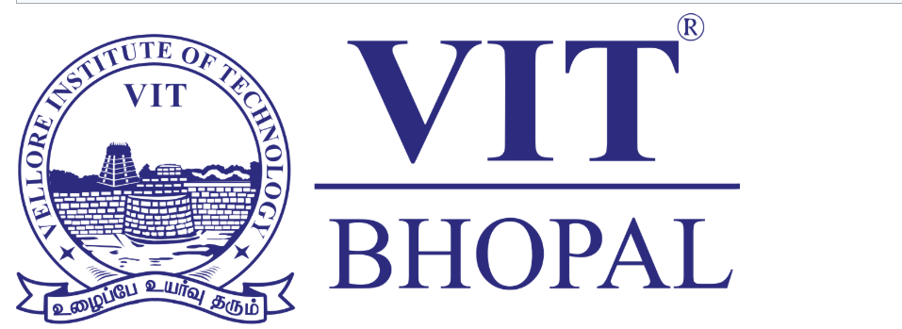

DIGITAL LITERACY PROJECT
VITYARTHI

Name: Charvi Agrawal
Registration Number: 25BCE10646
Branch: CSE Core
Year: 2025-2029
Course Code: CSE0001
Date: 27th March 2026

INTRODUCTION:
This project focuses on developing digital awareness and essential online skills required for students in today’s technology-driven world. As a Digital Ambassador, the aim is to guide peers in using online tools effectively for learning, collaboration, and communication. The project includes creating informative content on digital literacy, exploring coding practice platforms, and using Google Workspace tools for collaboration. It also emphasizes professional communication through email etiquette and responsible behavior on social media. Additionally, a cybercrime case study and prevention checklist were developed to raise awareness about online threats and safety practices. Overall, this project helps in building practical digital skills and encourages safe, responsible, and productive use of technology in academic and daily life.

TASK-1
In Task 1, I created an infographic on the topic of digital literacy, highlighting its importance and key components such as online safety, responsible internet use, and basic technical skills. The infographic was designed to be simple, visually appealing, and easy to understand so that it can effectively communicate the concept to students. I used an online design tool like Canva to create the infographic, as it provides ready-made templates, icons, and layouts that help in creating professional designs quickly.
While creating this infographic, I learned how to present information in a clear and visually engaging way instead of using long paragraphs. It helped me understand the importance of visual communication in spreading awareness.
One interesting part of this task was designing the infographic in a way that it looked visually attractive while still conveying meaningful information. It was challenging to decide what content to include and how to keep it concise without making it too crowded or confusing. However, this process helped me learn how to simplify complex ideas and present them effectively. I found it interesting to see how visual elements can make information more engaging and easier to remember compared to plain text.

TASK-2
In Task 2, I explored and set up accounts on platforms that support coding practice and professional networking. I chose HackerRank as my coding platform, which is used to practice programming skills, solve challenges, and improve problem-solving abilities. It also provides structured skill tests and certifications that are useful for placements. For professional networking, I created a LinkedIn profile, which helps in building a professional identity, connecting with peers and industry professionals, and exploring internship and job opportunities.
Over the next four years, I plan to regularly use HackerRank to strengthen my coding skills and prepare for technical interviews. I will use LinkedIn to showcase my projects, achievements, and skills, while also staying updated with industry trends and opportunities. Maintaining an active GitHub repository will help me organize my work and demonstrate my progress.
This task helped me understand the importance of building an online professional presence and consistently improving technical skills. It also improved my awareness of how these platforms contribute to academic and career growth.

TASK 3
In Task 3, I used HackerRank for coding practice and Google Workspace tools for collaboration. On HackerRank, I completed a beginner-level challenge, which helped me understand basic problem-solving techniques and improve my coding logic. Practising on this platform gave me hands-on experience in writing and testing code in a structured environment.
For the collaboration part, I created a Google Form titled “Digital Literacy Awareness Quiz” with five questions, including multiple-choice and short answer types. The form was linked to a Google Sheet to automatically collect and organize responses. This helped me understand how data can be collected and analyzed efficiently using cloud tools.
These platforms will be very useful academically, as HackerRank will help me prepare for coding exams and placements, while Google Forms and Sheets can be used for surveys, quizzes, and group projects. Overall, this task improved my technical skills, familiarity with online tools, and ability to use digital platforms effectively for learning and collaboration.

TASK 4

In Task 4, I practised professional communication by writing two formal emails and creating a social media Do’s and Don’ts checklist. The first email was written to a professor requesting an assignment deadline extension, and the second was addressed to an internship coordinator expressing interest in a summer internship. Both emails followed proper structure, including a clear subject line, professional greeting, well-organized body, and polite sign-off. This helped me understand the importance of tone, clarity, and respect in formal communication.
I also created a checklist highlighting responsible social media behavior, including key Do’s and Don’ts for college students. This ensured completeness and covered important aspects like privacy, professionalism, and respectful interaction online.
Through this task, I learned how to communicate effectively in different scenarios and maintain professionalism in digital interactions. These skills will be valuable for academic communication, internships, and future career opportunities.

TASK 5
While researching cybercrime, what surprised me the most was how simple and convincing many scams can be, especially phishing and UPI fraud. I learned that attackers often do not rely on complex hacking techniques but instead exploit human behavior, such as trust, urgency, or lack of awareness. It was surprising to see how easily someone can lose money or personal information just by clicking a link or approving a request without proper verification. I also realized that college students are a common target because they frequently use digital platforms but may not always be cautious.
As a result of this research, one important habit I plan to change is being more careful before clicking on links or responding to unknown messages. I will make it a practice to always verify the source, check URLs, and avoid sharing sensitive information without confirmation. This task has made me more aware and responsible as a digital user, and I will also encourage others to stay alert and follow safe online practices.
CONCLUSION
This project provided a comprehensive understanding of essential digital skills required in today’s world. Through different tasks, I learned about digital literacy, effective use of online platforms, professional communication, and awareness of cyber safety. Creating infographics and using tools like HackerRank and Google Forms helped me improve both my technical and creative skills. Writing professional emails and social media guidelines enhanced my communication abilities and understanding of online etiquette.
One of the most important learnings from this project was the importance of staying safe online and being aware of cyber threats. I also understood how digital tools can be used productively for academic growth and collaboration. Overall, this project has helped me become more confident, responsible, and aware as a digital user, and these skills will be useful throughout my academic and professional journey.

REFERENCES
Canva – for creating the infographic
HackerRank – for coding practice and completing beginner challenges
Google Forms and Google Sheets – for creating and managing the Digital Literacy quiz
GitHub – for uploading and organizing project files
LinkedIn – for creating a professional profile and networking
National Cyber Crime Portal – https://cybercrime.gov.in
General online resources and articles on digital literacy and cyber safety (for understanding concepts)

